C219 Front-end Web Development

**Lesson 1**

Worksheet

Understanding the Problem

1. What is the main reason Little Toy Kingdom wants to set up an online store?
2. What information would they need before creating an online store?

The Web Design Process

1. What are the steps involved in a web design process / workflow? Fill in the table below with the web design process stages and their description.

|  |  |
| --- | --- |
| **Web Design Process** | **Description** |
|  |  |
|  |  |

The Principles of Design

1. Recall the principles of design you have learnt from T252 Fundamentals of Design. List them below and describe what they mean.

|  |  |
| --- | --- |
| **Principles of Design** | **Description** |
|  |  |
|  |  |

1. Can these principles be applied to web design? Explain.

The Principles of Web Design

1. Conduct your own research and derive some principles of web design. Fill in the table below with the principles of web design together with an explanation.

|  |  |
| --- | --- |
| **Principles of Web Design** | **Description** |
|  |  |
|  |  |

Parts of a Web Page

1. What are the various parts of a web page? List them in the table below and describe them. Include a screenshot of a web page and label the parts.

|  |  |
| --- | --- |
| **Parts of a Web Page** | **Description** |
|  |  |
|  |  |

Website Analysis

1. Study [Shopee.sg](https://shopee.sg/). What is the main objective of this website?
2. Is this website a good example for Little Toy Kingdom to emulate? Why?
3. List a few effective websites for Little Toy Kingdom to refer to for inspiration. Provide reasons for your choices. You can list as many websites as you like.

|  |  |
| --- | --- |
| **Websites** | **Reasons** |
|  |  |
|  |  |

** Exercise 1 – Web Page Creation (Individual Work)**

1. Apply your prior knowledge in HTML and CSS to create a two-page website with the following key requirements:
   1. Page 1 – About Me
      * A heading
      * An image of yourself
      * A section containing information about you
   2. Page 2 – My Fav Food
      * A heading
      * An image of your favourite food
      * A short description about the food

Both pages should link to one another. You are not allowed to use any framework or template. You may add any other content that will enhance your web pages. Refer to [https://www.w3schools.com](https://www.w3schools.com/) for HTML and CSS tutorials.

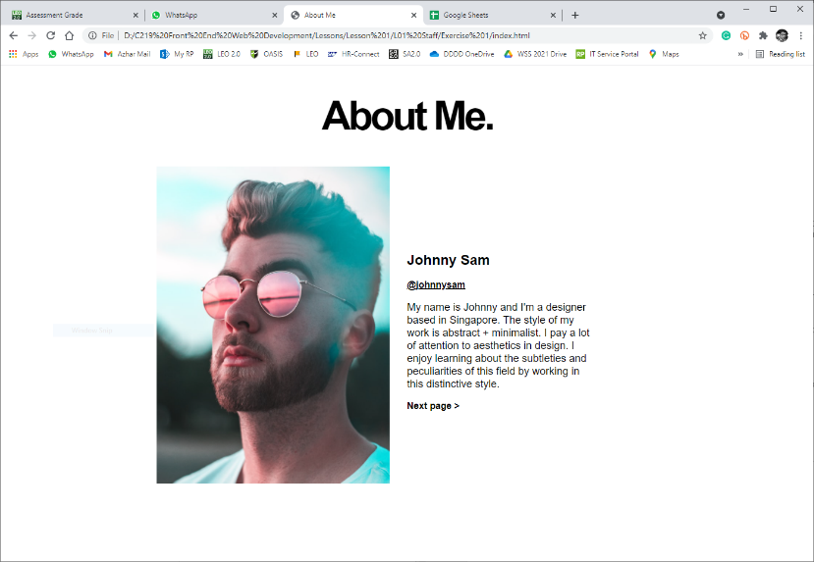

Page 1 Example

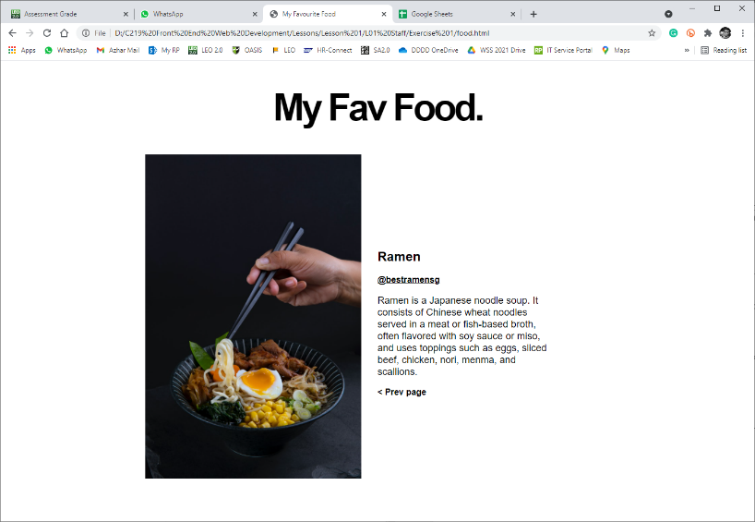

Page 2 Example

 **Solving the Problem (Teamwork)**

1. Create a website containing the information below:
   1. The principles of web design
   2. The parts of a web page
   3. A complete plan for the development of Little Toy Kingdom’s online store. You are to include details on the various stages in the web design process together with a project schedule / timeline.
   4. Two website examples for Little Toy Kingdom’s reference. Provide screenshots and reasons for your choices.

You may add more pages where necessary. You are not allowed to use any framework or template.

 **Deliverables**

Individual submission:

* Exercise 1

Team submission*:

* Worksheet
* Website^

* To be submitted by team leader only

^ Indicate your name on the web page(s) that you did

**Submit all deliverables by 3pm today.**